This is a screen shot of valve data for 100m in 30sec
S=0.21
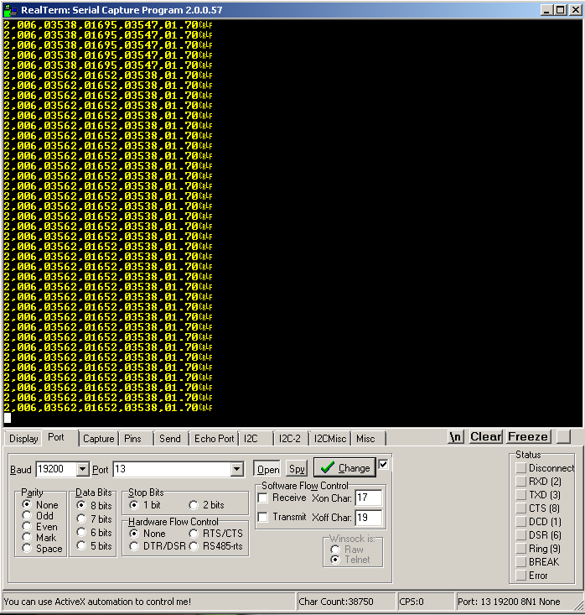

This is a screen shot of packet data for 100m in 40sec
S=0.16
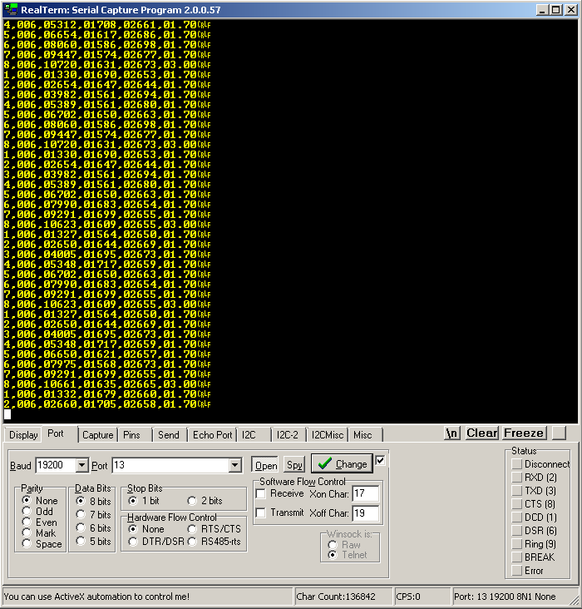

This is a screen shot of packet data for 100m in 45sec
S=0.14
