11 November 2021

To whom it may concern,

This serves to confirm that Mr. Siyabulela Shaun Ntulo, ID No. 880226 5711 086, is currently a temporary employee at Plot 58, corner of Driedoring Street and Road nr 10, Leeupoort Delmas.

Yours faithfully,
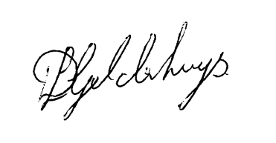
Mr DL Geldenhuys.
Technical Director

