RE: Proof of Residence

27 June 2016

To whom it may concern,

This is to certify that Mr DI Geldenhuys (ID No: 530813 5002 089) resides at 12 Smit Street.
His address is:

12 Smit Street,
Delmas,
2210,
Mpumalanga

Yours faithfully,

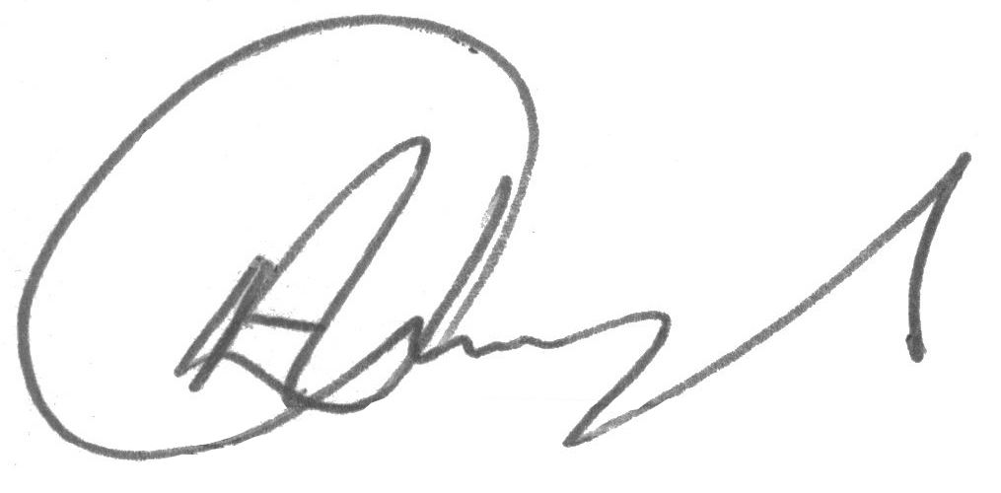
Mr AN Geldenhuys
OWNER

