11 March 2013

For Attention: Purchasing Department

Dear Customer,

Pricing of Products

Due to the increase in operational, labour, transport, electricity and maintenance costs as well as the increase in raw material prices it has been necessary for us to carry out a comprehensive review of the prices of products we supply to our customers.

You will appreciate that these cost factors are outside our control and we therefore have no alternative but to implement a price increase in respect of the products we supply to you.

Consequently, for all future orders the price of our products will be shown on the attached detailed listings of new prices.

The price increase will be effective from the 11th of March 2013. All orders placed before the date of this letter will be processed at the previous price.

Thank you for your valued support during the past and assuring you of our best service at all times.

Yours faithfully,

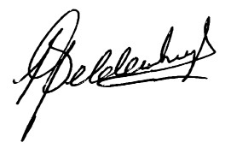
Leon Geldenhuys.
Managing Director

