17 August 2016

To whom it may concern,

This serves to confirm that Mr. Pieter Van Heerden, ID No. 7704225007087, was employed on a full-time basis by the above company from January 1996 to December 2001 at Factory 4, 39 Atlas Road, Dunswart, South Africa with a minimum of 40 hours worked per week.

During his employment, Mr. Van Heerden successfully completed his Tool, Jig and Die Making apprenticeship and thereafter went on to work as a qualified artisan. He later also qualified as a certified Milling and Turning CNC Programmer

His tasks included the following:
- The manufacture of new, and repairing of, jigs, fixtures and tools for metal pressings, plastic injection moulds, investment casting moulds, die casting moulds and sand casting patterns.

The following machines, tools, equipment and methods were employed:
- Conventional Machining (Milling and Turning): Manufacture machined and turned parts.
- CNC programming and machining (Milling and Turning): Programmed and operated Bridgeport Milling Machines (Hiedenhain), Dahlih Vertical Machining Centre with Fanuc control and Leadwell CNC Lathe with Fanuc control, to machine and produce required components and electrodes.
- Grinding: Surface (Churchill), Universal (Yam) and Centre less (Scrivener) grinding of components.
- Spark eroding: Die sinking.
- Hand and power tools.
- Measuring equipment (verniers, micrometers and gauges).
- Saws: power and band.
- Honing: Delapena.
- Tool assembly.

I hope serves as the confirmation you require. Should you have any further questions regarding Mr. Van Heerden’s employment, please do not hesitate to contact me at the above details.

Yours faithfully,
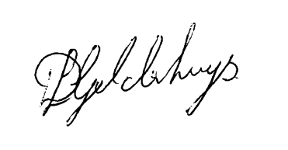
Mr DL Geldenhuys.
Technical Director

