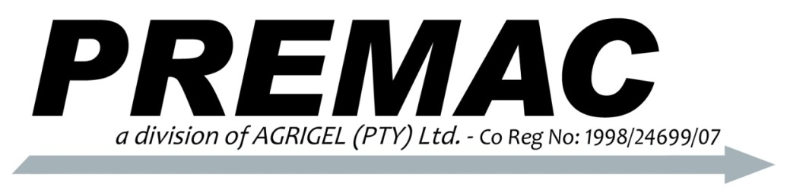
P.O. Box 2892
Delmas, 2210
Mpumalanga
Telephone: +2713 668 0000
Facsimile: +2786 659 8207
Email: info@premac.co.za
VAT No: 4810183410
www.premac.co.za
Manufacturers of Hydraulic Equipment

ACCESSORY VALVE RANGE

Premac manufactures a wide range of stack-type directional control valves and accessory valves. Premac has been manufacturing these valves locally in South Africa since 1989 and has proven its reliability, offering an extensive range of combinations and options to suit every requirement.

The range offers several safety features such as built-in main relief, anti-cavitational checks, load holding checks and port relief cartridges. These valves are manufactured to the highest specifications using the best material available to ensure a lasting good quality product.

SELECTOR VALVE

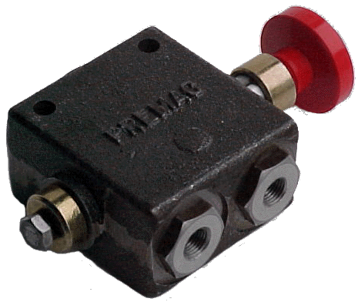
The two position selector valve offers a simple method of directing the flow of hydraulic oil to two separate lines. Two single acting cylinders can be operated by one control valve by adding a Selector Valve to the circuit.

SPECIFICATIONS:
Model : SVH-10
Capacity : 60 litres/min
Pressure Range : 138 Bar
Port Sizes : SAE-10

TECHNICAL:
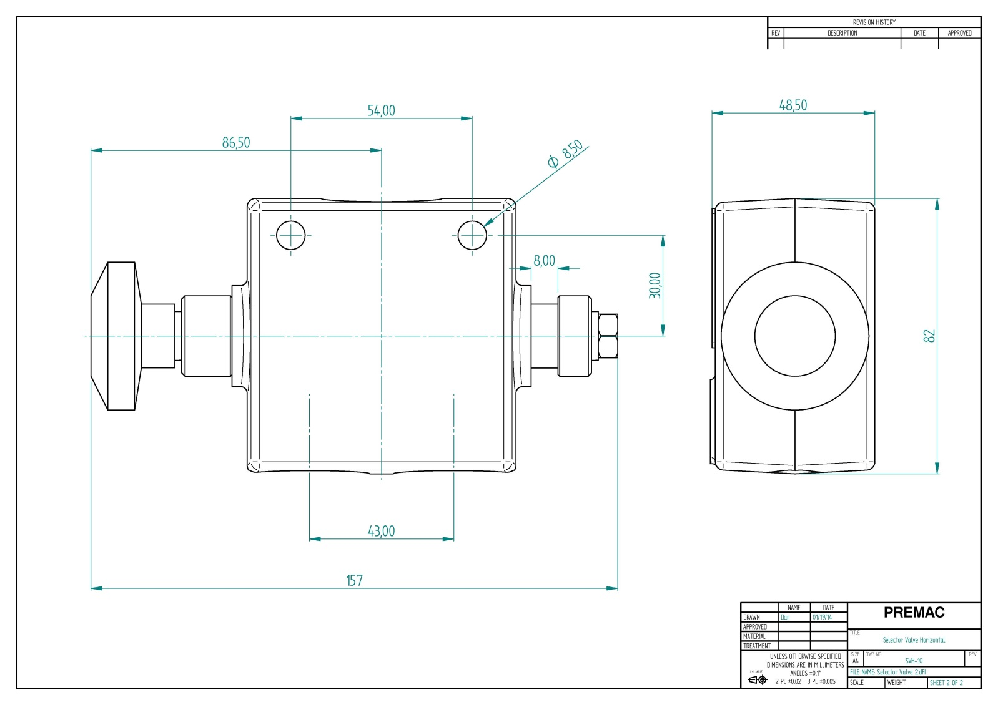
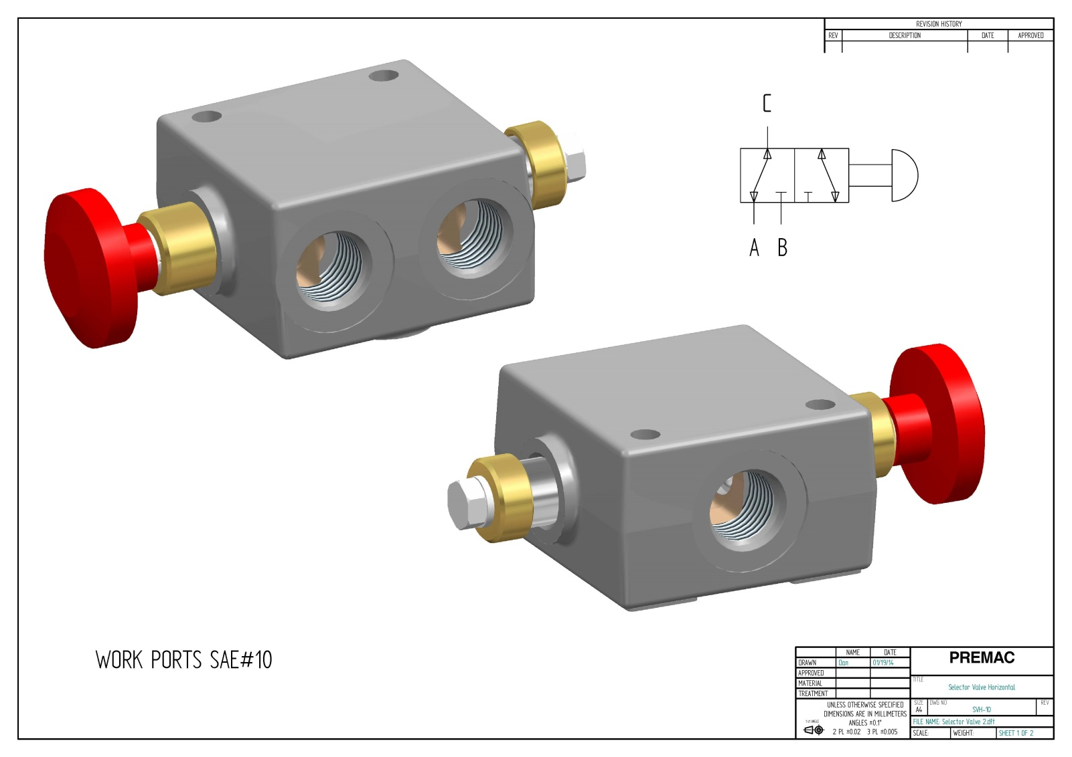
C
B
A

