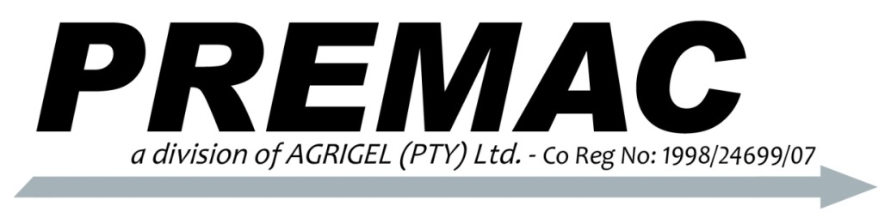
P.O. Box 2892
Delmas, 2210
Mpumalanga
Telephone: 013 668 0000
Facsimile: 086 659 8207
Email: info@premac.co.za
VAT No: 4810183410
www.premac.co.za
Manufacturers of Hydraulic Equipment

VALVE RANGE

The locally manufactured V75, V150, V200 and V260 stack type directional control valves are manufactured for the South African industrial, agricultural and mobile markets, offering an extensive range of combinations and options to suit every requirement.

Premac manufactures stack-type directional control valves that are equivalent to Gresen/Parker and Commercial valves. Premac has been manufacturing these valves locally in South Africa since 1989 and has proven its reliability, offering an extensive range of combinations and options to suit every requirement.

The range offers several safety features such as built-in main relief, anti-cavitational checks, load holding checks and port relief cartridges. These valves are manufactured to the highest specifications using the best material available to ensure a lasting good quality product.

Premac’s range offers valves with capacity’s ranging from 75 litres per minute through to 260 litres per minute. Each valves’ specifications are detailed below.

V75 VALVE RANGE
SPECIFICATIONS:
Capacity: 75 Litres/min
Working pressure: 240 Bar
Number of spools available: 9 sections
Spool options: 3 Way 3 Position
4 Way 3 Position
4 Way 4 Position Float
4 Way 3 Position Free Flow (Motor)
Actuator: Spring centered to neutral
3 Position Detent
2 Position Detent
Hydraulic Remote
Main Relief: Differential Pressure Poppet
Miscellaneous: Power Beyond
Open Centre
Closed Centre
Work Port Relief
Work Port Anti-Cavitation Check
Mid-inlet

Inlet Cover Work Section Outlet Cover
SAE12 SAE10 SAE12
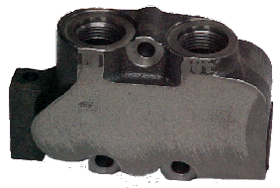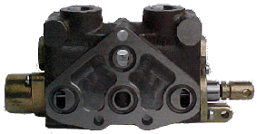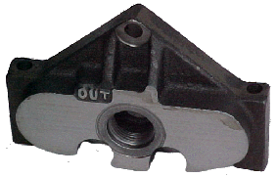
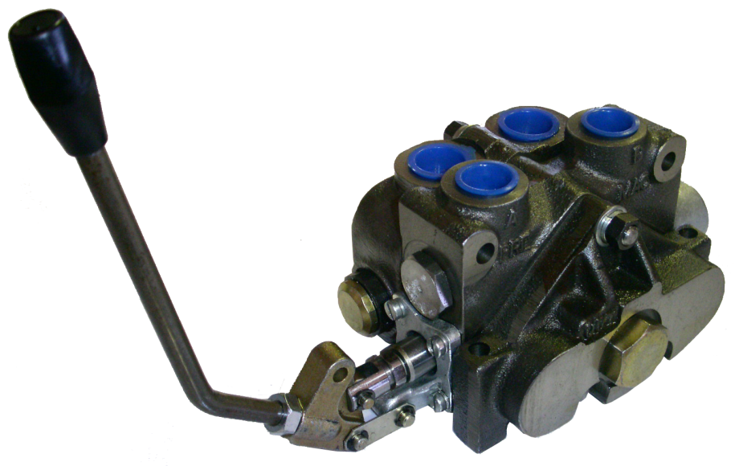

V150 VALVE RANGE
SPECIFICATIONS:
Capacity: 150 Litres/min
Working pressure: 210 Bar
Number of spools available: 9 sections
Spool options: 3 Way 3 Position
4 Way 3 Position
4 Way 4 Position Float
4 Way 4 Position Regenerative
4 Way 3 Position Free Flow (Motor)
Actuator: Spring centered to neutral
3 Position Detent
2 Position Detent
Hydraulic Remote
Main Relief: Differential Pressure Poppet
Miscellaneous: Power Beyond
Open Centre
Closed Centre
Conversion Plug
Load Holding Check
Work Port Relief
Work Port Anti-Cavitation Check

Inlet Cover Work Section Outlet Cover
SAE 16 or 20 SAE 12 or 16 SAE 20
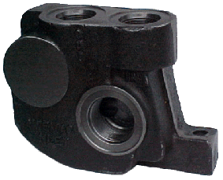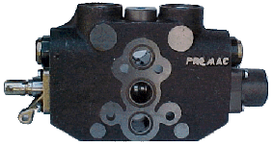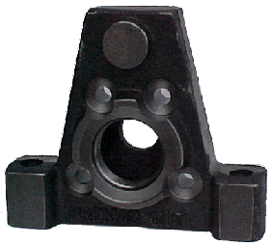
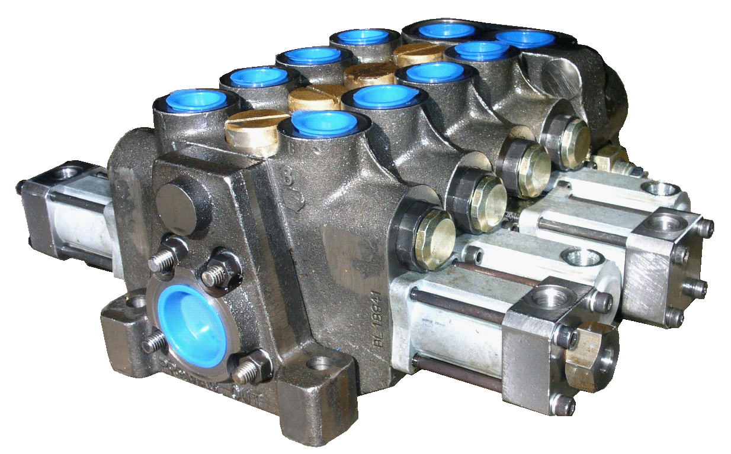
V200 VALVE RANGE
SPECIFICATIONS:
Capacity: 200 Litres/min
Working pressure: 210 Bar
Number of spools available: 8 sections
Actuator: Spring centered to neutral
3 Position Detent
2 Position Detent
Hydraulic Remote
Main Relief: Differential Pressure Poppet
Miscellaneous: Power Beyond
Open Centre
Closed Centre
Conversion Plug
Load Holding Check
Work Port Relief
Work Port Anti-Cavitation Check

Inlet Cover Work Section Outlet Cover
SAE 20 SAE 16 SAE 20
