13 August 2014

RE: Product/Service Line

Dear Sir/ Madam,

It is our pleasure to provide you with the products and services our organisation offers.

We manufacture, repair and service directional control valves for a variety of underground mining machinery, water and exploration drill rigs as well as truck cranes and 3 wheelers for sugar cane and logging.

We also manufacture a variety of accessory valves, manifolds and other accessories, such as manual air horns and sight level gauges, for these industries as mentioned above.

For more information on our products, please visit our website at www.premac.co.za

Yours faithfully,
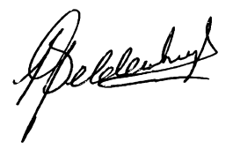
Leon Geldenhuys.
Managing Director

