Mr W Brodrick
Delmas

6 May 2020

RE: Marketing and distribution rights

Dearest sir,

It is with great pleasure that we, Premac a division of Agrigel (PTY) Ltd, manufacturers of the Face Shield, hereby grant marketing and distribution rights for our Face Shield product to Mr. William Brodrick within the mining and related industries.

Should you have any queries, or require more information in this regard, please feel free to contact me on 013 668 0000.

Yours sincerely,

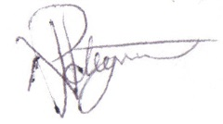
NICOLE POTGIETER
Finance Manager

