FAILURE REPORT

DATE: 28 November 2012

CUSTOMER: DBZ Diesel Parts – Cape Town

VALVE TESTED: V75 Single Bank Control Valve

FAILURE REPORT NUMBER: PAB0562

The following was found to be faulty with the above valve;
- Seals on Port Relief Plug were severely damaged
- Handle Assembly was broken beyond operational function

Possible reasons for failure:
- In our opinion, the IN and OUT Ports were connected incorrectly which resulted in the damage to the Port Relief Plug
- The Handle Assembly was damaged as a result of gross abuse

Yours faithfully,

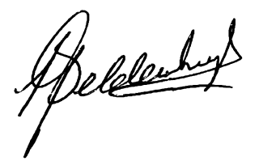
L.B. Geldenhuys
Managing Director

