SOUTH AFRICAN REVENUE SERVICES
30 May 2012

RE: REQUEST FOR DOCUMENTS AND COLLECTION AUTHORISATION:

To whom it may concern,

I, L.B. Geldenhuys, Managing Director of AGRIGEL (PTY) Ltd. with Company Registration Number: 1998/24699/07 and VAT Number: 4810183410, do hereby request that the following documents be furnished to the bearer of this letter:
- Copy of our VAT Certificate
- Letter of Good Standing of our company with SARS

Yours faithfully,

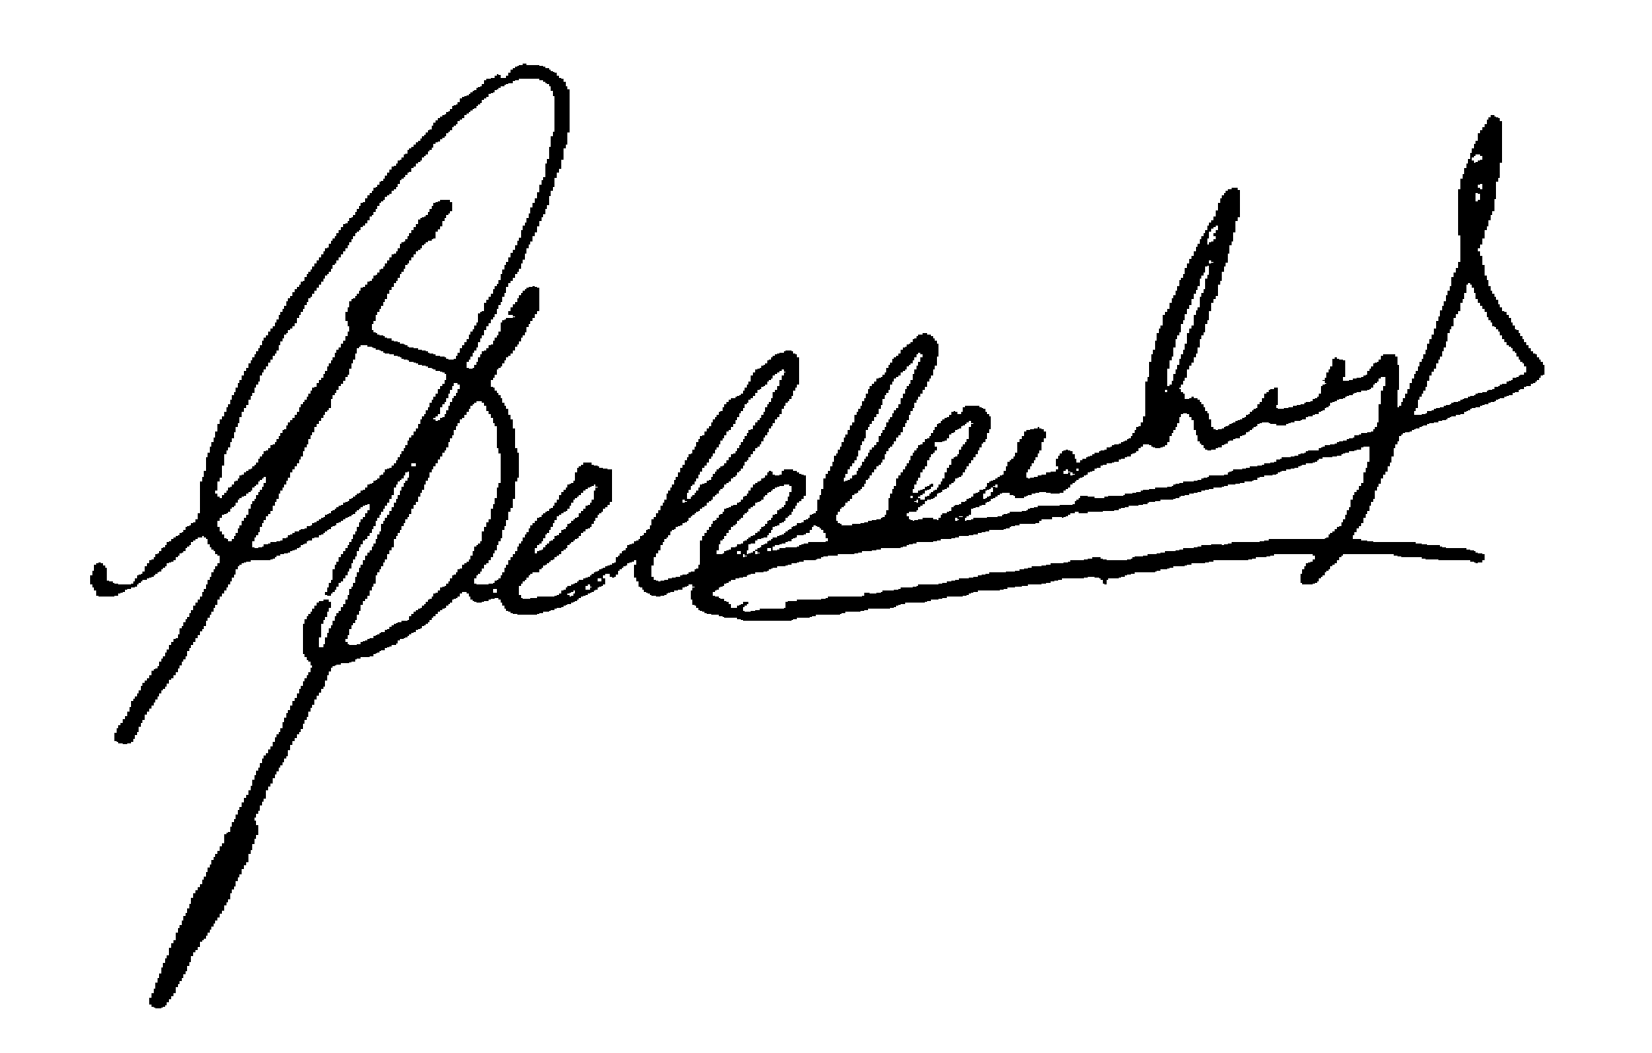
L.B. Geldenhuys
Managing Director

