24 November 2014

To: All our Valued Customers,

NOTICE OF ANNUAL SHUTDOWN

Please take note that our company will be closing for our annual shutdown from the 19th December 2014 and reopening again on the 12th January 2015.

Please ensure that all orders for the end of the year are placed with a reasonable lead-time in mind.

We thank you for your support over the past year and we wish to take this early opportunity to wish you and your families a blessed festive season and a prosperous new year filled with joy and happiness.

We look forward to continuing our services to you in 2015.

Best regards,

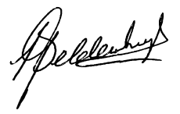
L.B. Geldenhuys
Managing Director

