THE DEPARTMENT OF TRADE, INDUSTRY AND COMPETITION

11 December 2020

RE: Resolution – Company representative

To whom it may concern,

We, LB Geldenhuys, Managing Director and DL Geldenhuys, Technical Director of Agrigel (PTY) Ltd, do hereby appoint and agree to Mrs NL Potigeter, our Finance Manager, being the authorised representative and contact person for our SPII application with the Department of Trade, Industry and Competition (dtic).

Signed at Delmas on this, 11 December 2020.

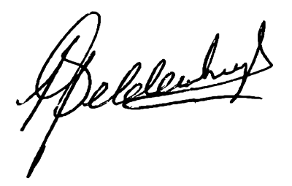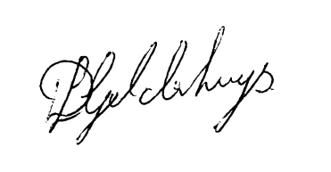
Leon Geldenhuys Daniel Geldenhuys
MANAGING DIRECTOR TECHNICAL DIRECTOR

