RE: BANKING DETAILS

11 October 2018

To whom it may concern,

This serves to confirm Agrigel (PTY) Ltd’s banking details, which are as follows:

Bank: Standard Bank
Branch: Delmas
Branch code: 052644
Account Number: 022 925 597
Account Type: Cheque

Yours faithfully,

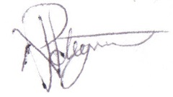
NL Potgieter
Financial Manager

